NAME: A.SANJAY KUMAR
Email : attellisanjay29@gmail.com
Date: 29-12-2025 a Day 2 – Querying & Modifying Data
Create a Sample Insurance database named InsuranceDB with tables, constraints, and initial sample data. Based on following a diagram and descriptions.
Entities we’ll model:
● Customers – people who buy insurance
● Policies – insurance products (Health, Motor, Life)
● Agents – insurance agents
● PolicyAssignments – which customer bought which policy
● Claims – claims raised against policies
Relationship Explanation
● One Customer → Many PolicyAssignments
● One Policy → Many PolicyAssignments
● One Agent → Many PolicyAssignments
● One PolicyAssignment → Many Claims

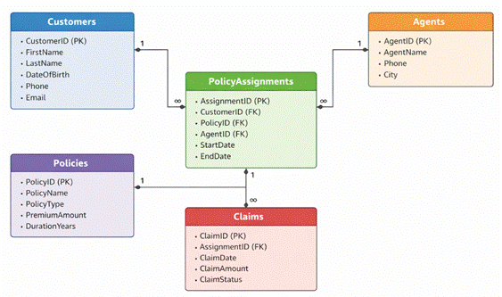

1. Create Database command
CREATE DATABASE insurance_db;
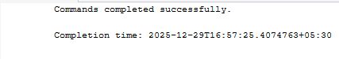

2. Create table commands for all tables
CREATE TABLE insurance_customers (
customer_id INT PRIMARY KEY,
first_name VARCHAR(50),
last_name VARCHAR(50),
dob DATE,
phone VARCHAR(15),
email VARCHAR(100),
created_at DATE,
updated_at DATE
);

Output:
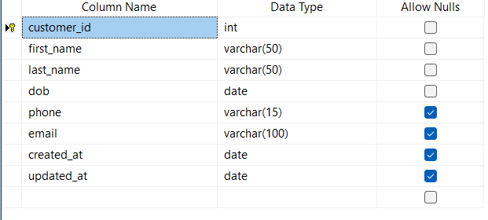

CREATE TABLE policies (
policy_id INT PRIMARY KEY,
policy_name VARCHAR(50),
policy_type VARCHAR(50),
pre_amount INT,
duration_year INT,
created_at DATE,
updated_at DATE
);
Output:
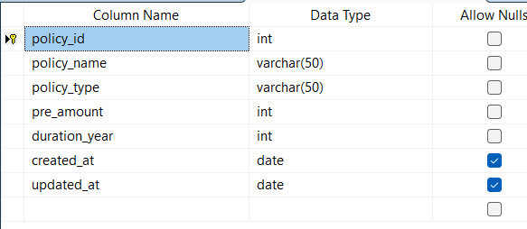

CREATE TABLE agents (
agent_id INT PRIMARY KEY,
agent_name VARCHAR(100),
phone VARCHAR(15),
city VARCHAR(50),
created_at DATE,
updated_at DATE
);
Output:
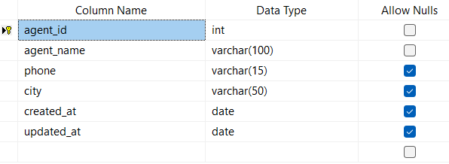

CREATE TABLE policy_assignments (
assignment_id INT PRIMARY KEY,
customer_id INT,
policy_id INT,
agent_id INT,
start_date DATE,
end_date DATE,
created_at DATE,
updated_at DATE,
FOREIGN KEY (customer_id) REFERENCES insurance_customers(customer_id),
FOREIGN KEY (policy_id) REFERENCES policies(policy_id),
FOREIGN KEY (agent_id) REFERENCES agents(agent_id)
);
Output:
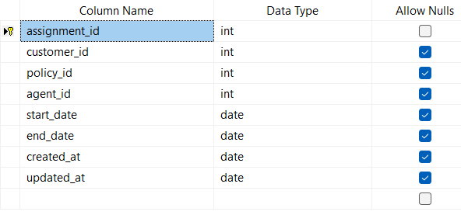
CREATE TABLE claims (
claim_id INT PRIMARY KEY,
assignment_id INT,
claim_date DATE,
claim_amount INT,
claim_status VARCHAR(30),
created_at DATE,
updated_at DATE,
FOREIGN KEY (assignment_id) REFERENCES policy_assignments(assignment_id)
);
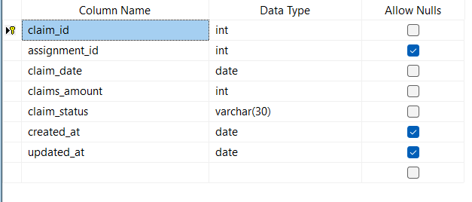
3. Insert commands for all tables
Data Inserted in to insurance_customers Table:

INSERT INTO insurance_customers VALUES
(1,'Sanjay','Attelli','2005-01-29','8919200290','sanjay.attelli@gmail.com','2024-01-05','2024-06-10'),
(2,'Manoj','Kumar','2004-05-25','9123456789','manoj.kumar@yahoo.com','2024-02-12','2024-07-01'),
(3,'Amit','Sharma','1998-04-12','9000000001','amit.sharma@gmail.com','2024-03-01','2024-06-01'),
(4,'Priya','Singh','1996-09-21','9000000002','priya.singh@gmail.com','2024-03-02','2024-06-02'),
(5,'Rahul','Verma','1994-01-15','9000000003','rahul.verma@yahoo.com','2024-03-03','2024-06-03'),
(6,'Neha','Gupta','2000-11-30','9000000004','neha.gupta@gmail.com','2024-03-04','2024-06-04'),
(7,'Vikas','Reddy','1992-07-18','9000000005','vikas.reddy@gmail.com','2024-03-05','2024-06-05'),
(8,'Pooja','Nair','1999-02-25','9000000006','pooja.nair@gmail.com','2024-03-06','2024-06-06'),
(9,'Arjun','Patel','1991-12-09','9000000007','arjun.patel@yahoo.com','2024-03-07','2024-06-07'),
(10,'Kiran','Das','1997-06-14','9000000008','kiran.das@gmail.com','2024-03-08','2024-06-08'),
(11,'Sneha','Joshi','1995-10-10','9000000009','sneha.joshi@gmail.com','2024-03-09','2024-06-09'),
(12,'Rohit','Mehta','1993-05-05','9000000010','rohit.mehta@gmail.com','2024-03-10','2024-06-10');
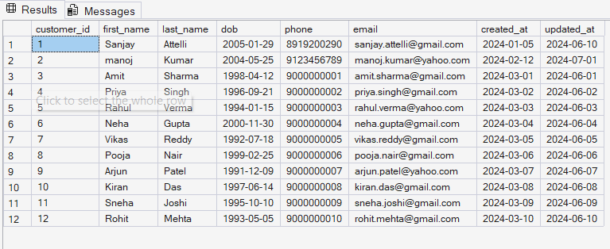

Data Inserted in to PoliciesTable:

INSERT INTO policies VALUES
(101,'Life Secure Plan','Life Insurance',12000,20,'2023-12-01','2024-05-01'),
(102,'Health Plus Policy','Health Insurance',8500,1,'2024-01-15','2024-06-20'),
(103,'Child Secure','Life Insurance',15000,18,'2024-02-01','2024-06-01'),
(104,'Senior Health','Health Insurance',22000,1,'2024-02-02','2024-06-02'),
(105,'Family Health Plus','Health Insurance',18000,2,'2024-02-03','2024-06-03'),
(106,'Term Life Gold','Life Insurance',25000,30,'2024-02-04','2024-06-04'),
(107,'Personal Accident','General Insurance',6000,1,'2024-02-05','2024-06-05'),
(108,'Travel Secure','Travel Insurance',4000,1,'2024-02-06','2024-06-06'),
(109,'Home Safe','Property Insurance',12000,10,'2024-02-07','2024-06-07'),
(110,'Vehicle Protect','Motor Insurance',9000,1,'2024-02-08','2024-06-08'),
(111,'Health Premium','Health Insurance',30000,3,'2024-02-09','2024-06-09'),
(112,'Life Platinum','Life Insurance',35000,25,'2024-02-10','2024-06-10');

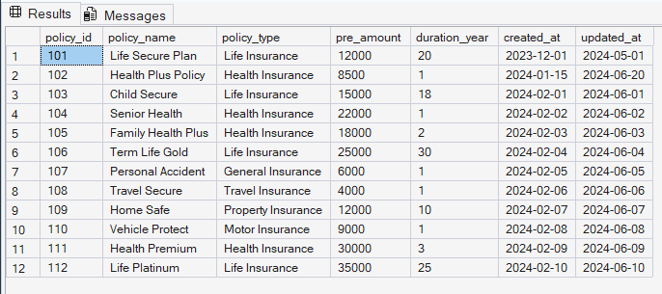

Data Inserted in to agents Table:

INSERT INTO agents VALUES
(5001,'Sanjay Kumar','8919200290','Hyderabad','2023-11-10','2024-04-12'),
(5002,'Monoj Kumar','9123456781','Delhi','2023-10-05','2024-03-18'),
(5003,'Varshith','9988776651','Chennai','2023-09-20','2024-02-25'),
(5004,'Amit Rao','9011111111','Mumbai','2023-08-01','2024-04-01'),
(5005,'Priya Shah','9011111112','Pune','2023-08-02','2024-04-02'),
(5006,'Rakesh Jain','9011111113','Delhi','2023-08-03','2024-04-03'),
(5007,'Sunita Roy','9011111114','Kolkata','2023-08-04','2024-04-04'),
(5008,'Deepak Mishra','9011111115','Bhopal','2023-08-05','2024-04-05'),
(5009,'Anil Kumar','9011111116','Chennai','2023-08-06','2024-04-06'),
(5010,'Meena Iyer','9011111117','Coimbatore','2023-08-07','2024-04-07'),
(5011,'Suresh Naik','9011111118','Goa','2023-08-08','2024-04-08'),
(5012,'Kavya Shetty','9011111119','Mangalore','2023-08-09','2024-04-09'),
(5013,'Nitin Kulkarni','9011111120','Nagpur','2023-08-10','2024-04-10');

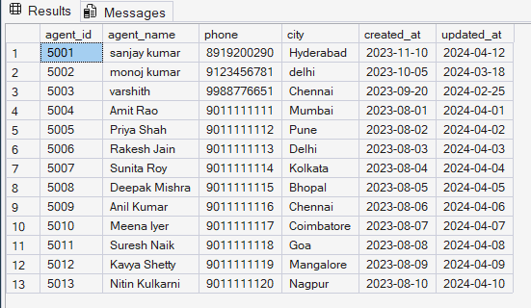

Data Inserted in to policy_assignments Table:
INSERT INTO policy_assignments VALUES
(1,1,101,5001,'2024-01-01','2044-01-01','2024-01-02','2024-06-01'),
(2,2,102,5002,'2024-06-15','2025-06-15','2024-06-16','2024-07-10'),
(3,3,103,5004,'2024-01-10','2042-01-10','2024-01-11','2024-06-01'),
(4,4,104,5005,'2024-02-01','2025-02-01','2024-02-02','2024-06-02'),
(5,5,105,5006,'2024-03-01','2026-03-01','2024-03-02','2024-06-03'),
(6,6,106,5007,'2024-04-01','2054-04-01','2024-04-02','2024-06-04'),
(7,7,107,5008,'2024-05-01','2025-05-01','2024-05-02','2024-06-05'),
(8,8,108,5009,'2024-06-01','2025-06-01','2024-06-02','2024-06-06'),
(9,9,109,5010,'2024-07-01','2034-07-01','2024-07-02','2024-06-07'),
(10,10,110,5011,'2024-08-01','2025-08-01','2024-08-02','2024-06-08'),
(11,11,111,5012,'2024-09-01','2027-09-01','2024-09-02','2024-06-09'),
(12,12,112,5013,'2024-10-01','2049-10-01','2024-10-02','2024-06-10');
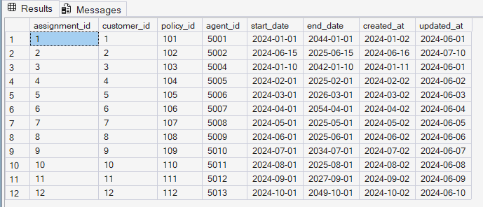

Data Inserted in to claims Table:
INSERT INTO claims VALUES
(1,1,'2024-03-10',50000,'Approved','2024-03-11','2024-03-20'),
(2,2,'2024-08-05',12000,'Pending','2024-08-06','2024-08-15'),
(3,3,'2024-04-15',20000,'Approved','2024-04-16','2024-04-20'),
(4,4,'2024-05-10',15000,'Pending','2024-05-11','2024-05-18'),
(5,5,'2024-06-05',30000,'Rejected','2024-06-06','2024-06-12'),
(6,6,'2024-07-01',50000,'Approved','2024-07-02','2024-07-10'),
(7,7,'2024-08-12',8000,'Pending','2024-08-13','2024-08-20'),
(8,8,'2024-09-18',12000,'Approved','2024-09-19','2024-09-25'),
(9,9,'2024-10-22',25000,'Approved','2024-10-23','2024-10-30'),
(10,10,'2024-11-05',9000,'Rejected','2024-11-06','2024-11-12'),
(11,11,'2024-11-20',40000,'Pending','2024-11-21','2024-11-28'),
(12,12,'2024-12-01',60000,'Approved','2024-12-02','2024-12-10');

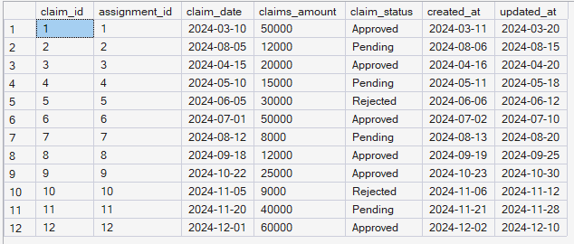

4. View all records from insurance_customers
SELECT * FROM insurance_customers;

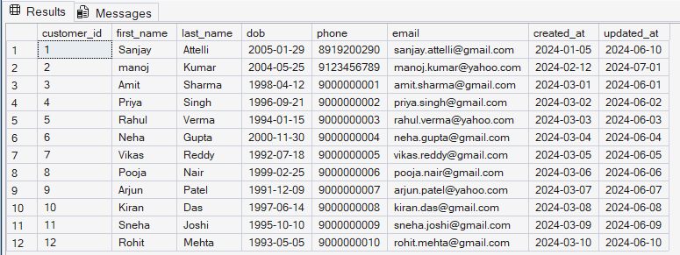
5. View PolicyAssignments with CustomerId, PolicyId, StartDate, EndDate
SELECT customer_id, policy_id, start_date, end_date
FROM policy_assignments;

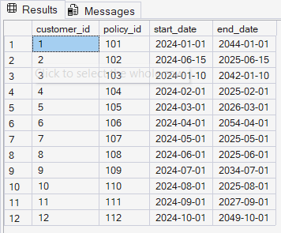

6. Display all policies of Health type
SELECT * FROM policies
WHERE policy_type = 'Health Insurance';
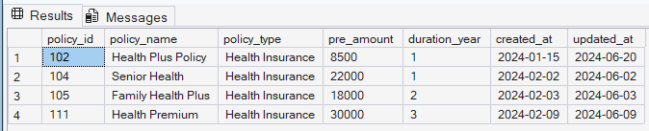

7. Premium > 10000 and DurationYears = 1
SELECT * FROM policies
WHERE pre_amount > 10000 AND duration_year = 1;
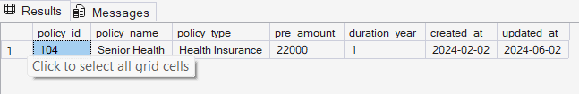

8. Display unique agent city names
SELECT DISTINCT city FROM agents;
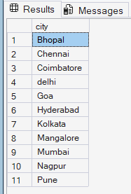

9. Policies using OR
SELECT * FROM policies
WHERE policy_type = 'Life Insurance'
OR policy_type = 'Health Insurance'
OR policy_type = 'Motor Insurance';
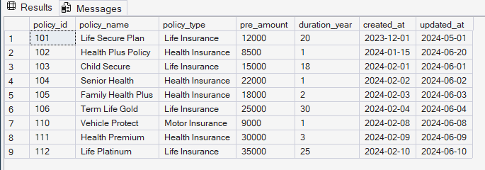
10. Policies using IN
SELECT * FROM policies
WHERE policy_type IN ('Life Insurance','Health Insurance','Motor Insurance');
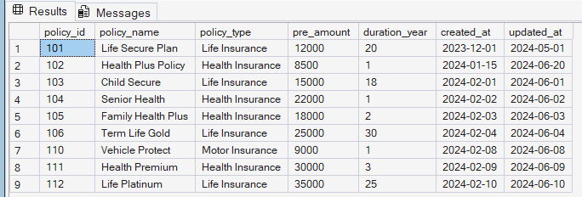
11. Customers born using >= and <=
SELECT * FROM insurance_customers
WHERE dob >= '2001-01-01' AND dob <= '2020-12-31';
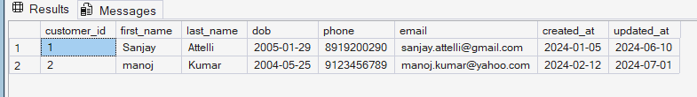

12. Customers born using BETWEEN
SELECT * FROM insurance_customers
WHERE dob BETWEEN '2001-01-01' AND '2020-12-31';
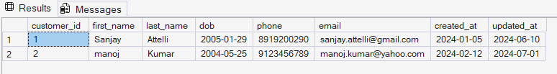

13. Claims with Rejected status
SELECT * FROM claims
WHERE claim_status = 'Rejected';
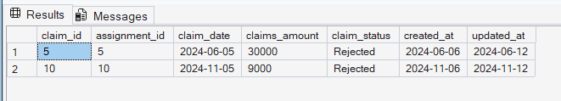
14. Agents staying in city whose second letter is 'a'
SELECT * FROM agents
WHERE city LIKE '_a%';
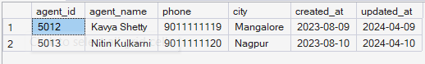
15. Highest and Lowest claim amount
SELECT MIN(claim_amount) AS min_claim,
MAX(claim_amount) AS max_claim
FROM claims;
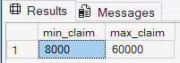
16. Latest claim record
SELECT TOP 1 *
FROM claims
ORDER BY claim_date DESC;
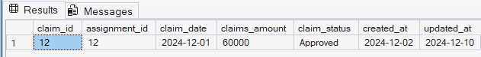
17. Increase Health policy premium by 10%
UPDATE policies
SET pre_amount = pre_amount * 1.10
WHERE policy_type = 'Health Insurance';
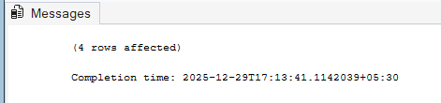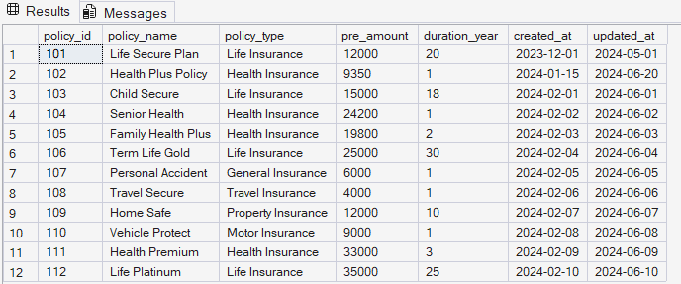
18. Delete PolicyAssignments whose EndDate is before today
DELETE FROM policy_assignments
WHERE end_date < GETDATE();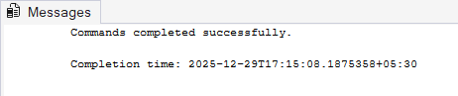

19. Number of rejected claims
SELECT COUNT(*) AS rejected_claims
FROM claims
WHERE claim_status = 'Rejected';
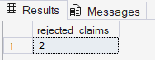

20. Computed premium fields
SELECT policy_id,
policy_name,
pre_amount,
pre_amount * 0.06 AS local_taxes,
pre_amount * 1.06 AS premium_with_tax,
(pre_amount * 1.06) / 12 AS monthly_premium
FROM policies;
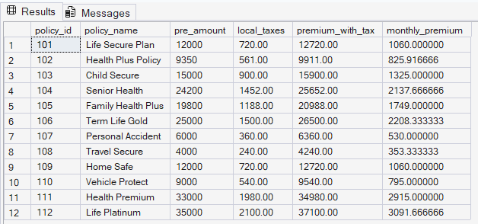
21. Add Address and City columns to Customers
ALTER TABLE insurance_customers
ADD address VARCHAR(200), city VARCHAR(50);


22. Add DevOfId column to Agents
ALTER TABLE agents
ADD DevOfId INT;
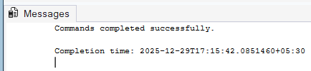
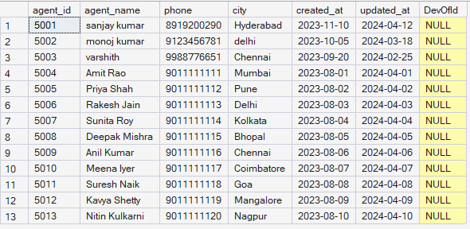

23. Make DevOfId recursive foreign key
ALTER TABLE agents
ADD CONSTRAINT fk_dev_agent
FOREIGN KEY (DevOfId) REFERENCES agents(agent_id);
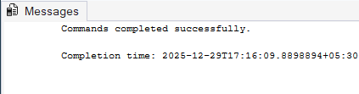
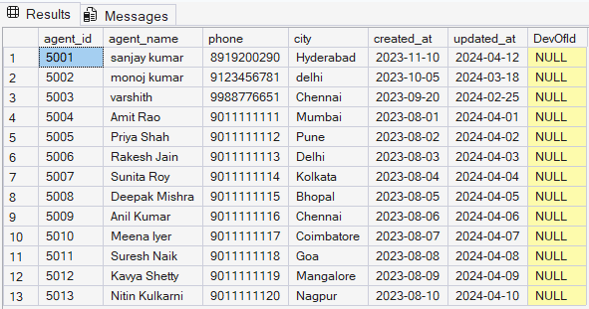
24. List all policies for CustomerId = 5
SELECT p.*
FROM policies p
JOIN policy_assignments pa
ON p.policy_id = pa.policy_id
WHERE pa.customer_id = 5;
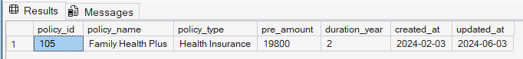
25. View all customers with their policies
SELECT c.first_name, c.last_name, p.policy_name
FROM insurance_customers c
JOIN policy_assignments pa
ON c.customer_id = pa.customer_id
JOIN policies p
ON pa.policy_id = p.policy_id;
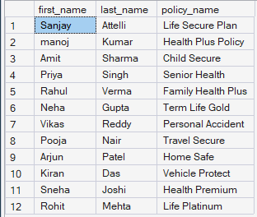

26. View claims with customer name
SELECT c.first_name, c.last_name, cl.claims_amount
FROM insurance_customers c
JOIN policy_assignments pa
ON c.customer_id = pa.customer_id
JOIN claims cl
ON pa.assignment_id = cl.assignment_id;
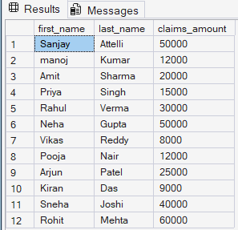

27. FirstName, PolicyName, AgentName, StartDate, EndDate
SELECT c.first_name,
p.policy_name,
a.agent_name,
pa.start_date,
pa.end_date
FROM policy_assignments pa
JOIN insurance_customers c ON pa.customer_id = c.customer_id
JOIN policies p ON pa.policy_id = p.policy_id
JOIN agents a ON pa.agent_id = a.agent_id;
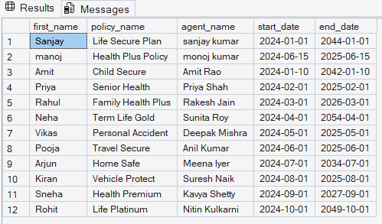

28. Claims report with details
SELECT c.first_name,
p.policy_name,
cl.claims_amount,
cl.claim_status,
cl.claim_date
FROM claims cl
JOIN policy_assignments pa ON cl.assignment_id = pa.assignment_id
JOIN insurance_customers c ON pa.customer_id = c.customer_id
JOIN policies p ON pa.policy_id = p.policy_id;
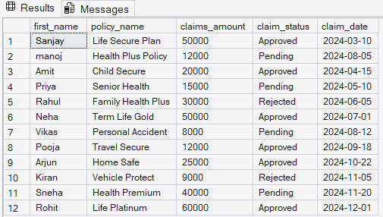
29. Customers with or without policies
SELECT c.*
FROM insurance_customers c
LEFT JOIN policy_assignments pa
ON c.customer_id = pa.customer_id;
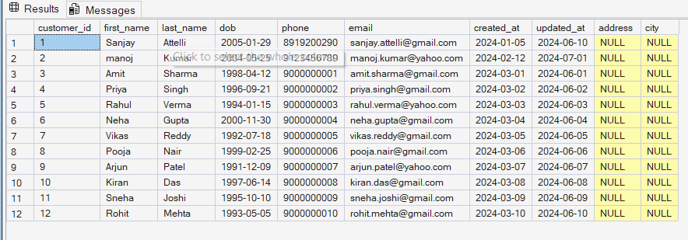

30. Customers with NO claims
SELECT DISTINCT c.*
FROM insurance_customers c
LEFT JOIN policy_assignments pa ON c.customer_id = pa.customer_id
LEFT JOIN claims cl ON pa.assignment_id = cl.assignment_id
WHERE cl.claim_id IS NULL;
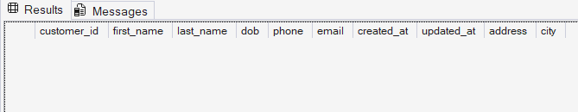
31. Customer-wise total claim amount
SELECT c.first_name,
SUM(cl.claims_amount) AS total_claim_amount
FROM insurance_customers c
JOIN policy_assignments pa ON c.customer_id = pa.customer_id
JOIN claims cl ON pa.assignment_id = cl.assignment_id
GROUP BY c.first_name;
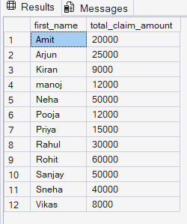

32. Agent-wise policy count
SELECT a.agent_name,
COUNT(pa.policy_id) AS policy_count
FROM agents a
JOIN policy_assignments pa ON a.agent_id = pa.agent_id
GROUP BY a.agent_name;
